**ASSIGNMENT-3**

Bucket Images

|  |  |
| --- | --- |
| Assignment Date | 11 October - 2022 |
| Student Name | Jayasurya J |
| Student Roll No | 922519205048 |
| Maximum Marks | 2 Marks |

**Question-1:**

Create a Bucket in IBM object storage.

**Solution:**

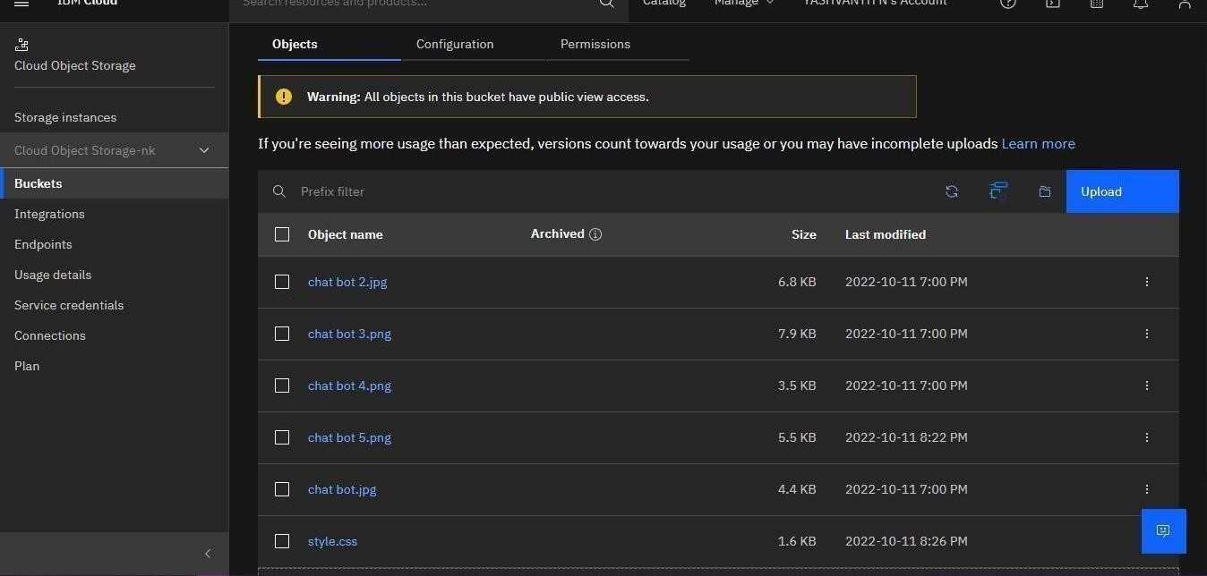

**Question-2:**

Upload an 5 images to ibm object storage and make it public. write html code to displaying all the 5 images.

**Solution:**

|  |
| --- |
| <!DOCTYPE html>  <html lang="en">  <head>  <meta charset="UTF-8">  <meta http-equiv="X-UA-Compatible" content="IE=edge">  <meta name="viewport" content="width=device-width, initial-scale=1.0">  <title>Bucket</title>  </head>  <body>  <img src="https://s3.au-syd.cloud-object-storage.appdomain.cloud/my- bucket24/chat%20bot.jpg">  <img src="https://s3.au-syd.cloud-object-storage.appdomain.cloud/my- bucket24/chat%20bot%202.jpg">  <img src="https://s3.au-syd.cloud-object-storage.appdomain.cloud/my- bucket24/chat%20bot%203.png">  <img src="https://s3.au-syd.cloud-object-storage.appdomain.cloud/my- bucket24/chat%20bot%204.png"> |

<img src="https://s3.au-syd.cloud-object-storage.appdomain.cloud/my- bucket24/chat%20bot%205.png">

</body>

</html>

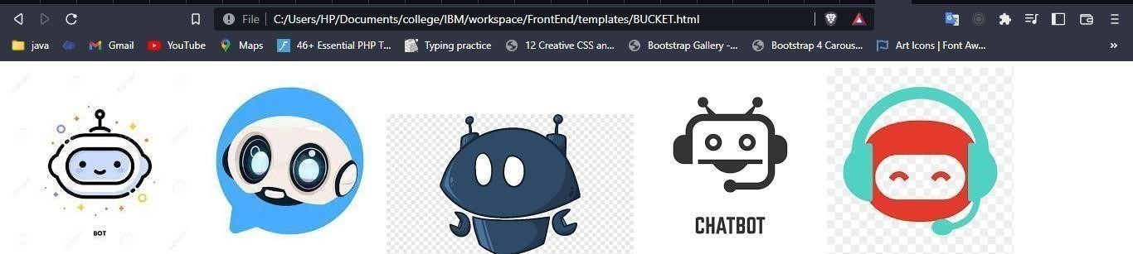

**Question-3:**

Upload a css page to the object storage and use the same page in your HTML code.write html code to displaying all the 5 images.

**Solution:**

|  |
| --- |
| <html>  <head>  <meta charset="utf-8">  <meta name="viewport" content="width=device-width, initial-scale=1,  shrink-to-fit=no">  <link rel="stylesheet" href="https://maxcdn.bootstrapcdn.com/font-  awesome/4.7.0/css/font-awesome.min.css">  <link rel="stylesheet"  href="https://stackpath.bootstrapcdn.com/bootstrap/4.5.0/css/bootstrap.min.css ">  <link rel="stylesheet"  href="https://cdnjs.cloudflare.com/ajax/libs/particlesjs/2.2.3/particles.min.j s">  <link rel="stylesheet" href="https://s3.au-syd.cloud-object-  storage.appdomain.cloud/my- bucket24/style.cssxxxxxxxxxxxxxxxxxxx"> </head>    <body> |

**Question-4:**

Design a chatbot using IBM Watson assistant for hospital. Ex: User comes with query to know the branches for that hospital in your city. Submit the web URL of that chat bot as a assignment.

**Solution:**

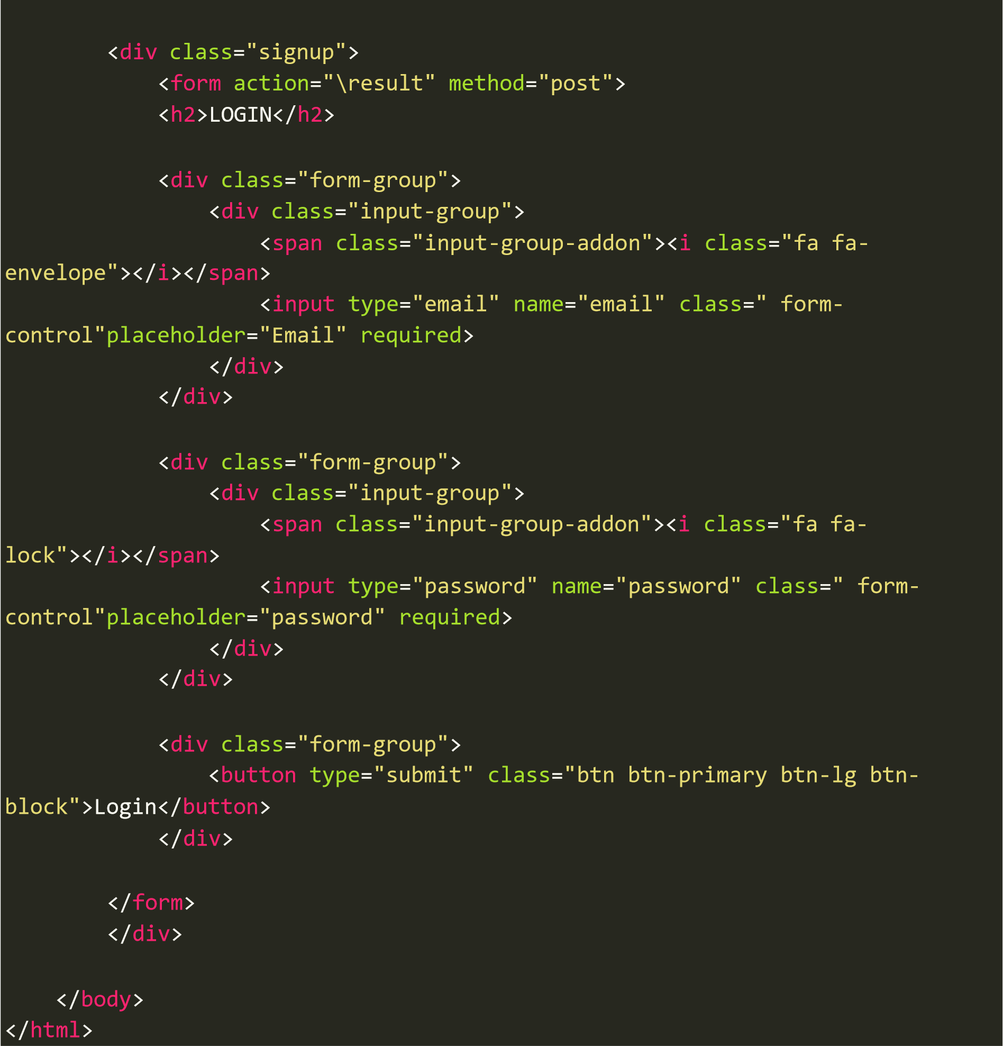

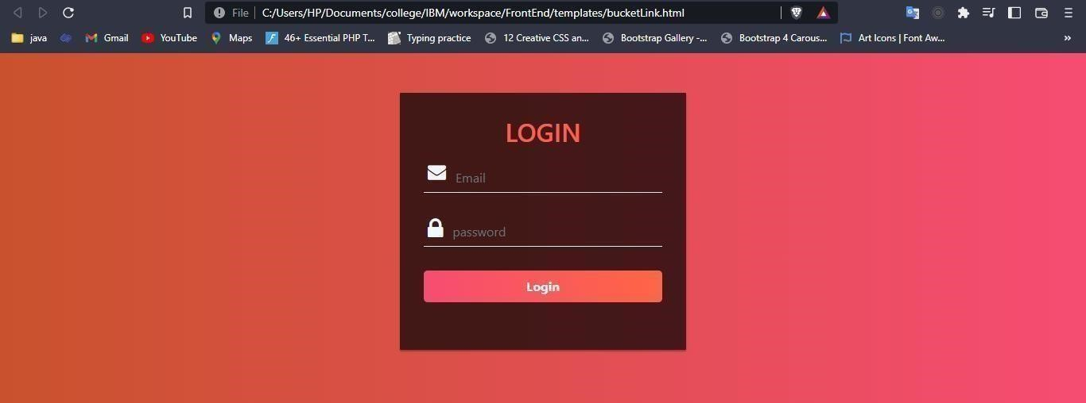

[https://web-](https://web-chat.global.assistant.watson.appdomain.cloud/preview.html?backgroundImageURL=https%3A%2F%2Fau-syd.assistant.watson.cloud.ibm.com%2Fpublic%2Fimages%2Fupx-f8e994d6-a0d7-422f-a9f3-852a308d5f26%3A%3A9313e8ba-e53d-470d-8fb1-7db9327ba407&integrationID=4eb80521-2d5d-4e2b-ac4b-5124347d8655&region=au-syd&serviceInstanceID=f8e994d6-a0d7-422f-a9f3-852a308d5f26)

[chat.global.assistant.watson.appdomain.cloud/preview.html?backgroundImageURL=https%3A%2F% 2Fau-syd.assistant.watson.cloud.ibm.com%2Fpublic%2Fimages%2Fupx-f8e994d6-a0d7-422f-a9f3- 852a308d5f26%3A%3A9313e8ba-e53d-470d-8fb1-7db9327ba407&integrationID=4eb80521-2d5d-](https://web-chat.global.assistant.watson.appdomain.cloud/preview.html?backgroundImageURL=https%3A%2F%2Fau-syd.assistant.watson.cloud.ibm.com%2Fpublic%2Fimages%2Fupx-f8e994d6-a0d7-422f-a9f3-852a308d5f26%3A%3A9313e8ba-e53d-470d-8fb1-7db9327ba407&integrationID=4eb80521-2d5d-4e2b-ac4b-5124347d8655&region=au-syd&serviceInstanceID=f8e994d6-a0d7-422f-a9f3-852a308d5f26)

[4e2b-ac4b-5124347d8655&region=au-syd&serviceInstanceID=f8e994d6-a0d7-422f-a9f3- 852a308d5f26](https://web-chat.global.assistant.watson.appdomain.cloud/preview.html?backgroundImageURL=https%3A%2F%2Fau-syd.assistant.watson.cloud.ibm.com%2Fpublic%2Fimages%2Fupx-f8e994d6-a0d7-422f-a9f3-852a308d5f26%3A%3A9313e8ba-e53d-470d-8fb1-7db9327ba407&integrationID=4eb80521-2d5d-4e2b-ac4b-5124347d8655&region=au-syd&serviceInstanceID=f8e994d6-a0d7-422f-a9f3-852a308d5f26)

**Question-5:**

Create Watson assistant service with 10 steps and use 3 conditions in it. Load that script in HTML page.

**Solution:**

|  |
| --- |
| <!DOCTYPE html>  <html lang="en">  <head>  <meta charset="UTF-8">  <meta http-equiv="X-UA-Compatible" content="IE=edge">  <meta name="viewport" content="width=device-width, initial-scale=1.0">  <title>Document</title>  </head>  <body>  <script> window.watsonAssistantChatOptions = { integrationID: "d5aae4c6-7146-  488c-8235-4a7abe46526d", // The ID of this integration.  region: "au-syd", // The region your integration is hosted in.  serviceInstanceID: "f8e994d6-a0d7-422f-a9f3-852a308d5f26", // The ID of  your service instance.  onLoad: *function*(*instance*) { *instance*.render(); }  };  setTimeout(*function*(){ *const* t=document.createElement('script'); t.src="https://web-  chat.global.assistant.watson.appdomain.cloud/versions/" +  (window.watsonAssistantChatOptions.clientVersion || 'latest') +  "/WatsonAssistantChatEntry.js"; document.head.appendChild(t);  });  </script>        </body>  </html> |

